Odour Filter Installation
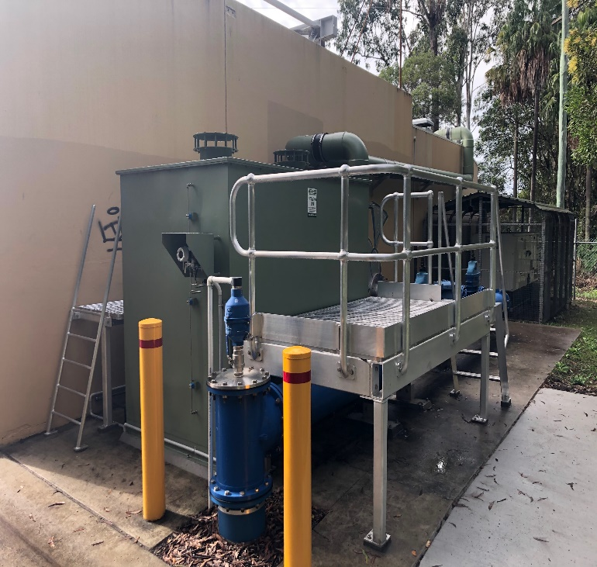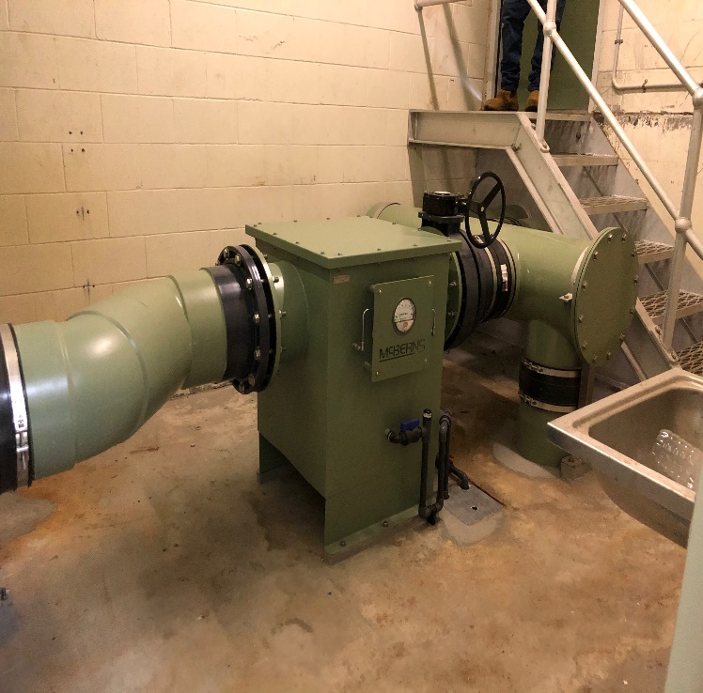

McBerns install a custom built ZC8000 to suit site requirements, odour was becoming a problem for the local community, now 99.9% of all emissions from the pump station are being treated.
This installation was quite unique as there were restrictions within the pump station building itself and around existing pipework externally.
McBerns pride themselves on being able to design ,fabricate, install and commission an Odour Control unit to suit your specific requirments.

